Install Citrix Receiver on Mac

If you have Admin rights on your Mac
- Go to: http://atnyulmc.org/help-documentation/installation-downloads/CitrixExternal
- Download the CitrixReceiver129.dmg by clicking on “Citrix Client for Macs”
- Double click to install
  - At the Account/Email prompt, just hit cancel/close

If you DON’T have Admin rights on your Mac
Install Citrix Receiver with MCIT Software Installer

- Connect to the NYU intranet using the Advance VPN access
  - Follow instructions at http://atnyulmc.org/help-documentation/NYU-Langone-Advanced-Access-App if you’re not familiar with Advance VPN access.

- On the Dock, double click on MCIT Software Installer

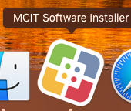

- Find Citrix Receiver and click install. An icon for the Citrix application will be placed at the end of your dock.

